VRF-Lite Lab

Purpose

The purpose of the VRF lab was to have us learn about VRFs and how they can be used to separate PCs and routers into different virtual routing tables. This concept is useful for us as it is very important in the workplace to be used to organize many different clients into their own private routing tables.

Background Information

Virtual routing and forwarding, or VRF, is a technology that allows multiple instances of a routing table to co-exist within the same router at the same time. Normally, a problem with routers is that they have a single routing table that stores IP addresses, and this can be a problem with large amounts of customers. What VRF allows you to do is create multiple virtual routing tables that can contain the same overlapping IP addresses without causing conflicts. This improves network functionality because it segments the network paths without requiring the use of multiple routers. Using VRFs is extremely useful as it not only improves network functionality, but it allows different customers to be easily organized into their own VRF. This allows each customer to have access to their own routing table which contains IP addresses which will not conflict with those of other customers.

Lab Summary

In this lab, I segmented a topology of three routers and four PCs into two different VRFs, which each had their own routing table and IPs and did not overlap. I started the setup of this lab by configuring all three routers and PCs with their IPv4 addresses. I split each of the interfaces between the routers into two different subinterfaces, one representing each VRF. Next, I began setting up the VRFs on the middle router R2. I setup VRF 10 for PCs one and three, and VRF 20 for PCs two and four. Next, I forwarded each VRF through their respective interfaces on R2 and then re-added the IP addresses to those interfaces. Now, R2’s routing table was empty, and its VRF routing tables were full, but only with the directly connected interfaces. I then configured OSPF between the routers, with two instances, one for each VRF. I added each VRF 10 network to OSPF 1, and each VRF 20 network to OSPF 2. After the VRFs and OSPF were set up, R2 now had two virtual routing tables containing IPs 192.168.1.0 to 192.168.4.0 for VRF 10, and IPs 192.168.5.0 to 192.168.8.0 for VRF 20. After this, I checked that I had it working by examining the routing table on R2, which was empty unless I looked at the routing table for each VRF, which contained two directly connected networks and two OSPF networks.

Lab Commands

For this lab, there were multiple different commands that I had to learn in order to set up the VRFs successfully. The first thing I had to do was set up the VRFs. This is done by using the command “ip vrf 10” which can be used to set up a VRF with either a name or a number. Next, I had to forward the VRFs on the subinterfaces using the command “ip vrf forwarding 10,” which I used on all the subinterfaces leading out of R2, though with different VRF names. I also had to setup OSPF a little bit differently, by adding “vrf 10” to the command like this: “router ospf 1 vrf 10.” This set up that OSPF instance under VRF 10, and I repeated the step for VRF 20. After this, I also had to learn a few new troubleshooting commands, such as “ip route vrf 10,” which is used to check the routing table of VRF 10.

Problems

While setting up this lab, I didn’t have that many problems. This lab was rather easy to do, so it did not take me very long to complete it. The only problems I did have were with subinterfaces, VRF forwarding, and OSPF. My first problem was that I did not use subinterfaces. I tried to configure multiple VRFs without the use of subinterfaces, but I could not figure it out, and it was pretty easy to do after I configured those. My next problem was after using the “ip vrf forwarding 10” command, which removed the IP address from the interfaces after it was used. I did not realize this initially, and it took me a little while to figure out that the interfaces were missing their IP addresses. Once I re-added those, it started working again. My final problem was within OSPF. I originally used the network statement “network 0.0.0.0 0.0.0.0 255.255.255.255 area 0,” which would add any networks it detected to the routing table. This turned out to be a problem because it was adding all the networks to its table, not just the ones in the VRF. I then changed the command to multiple network commands, one for each network, and then VRF worked like it was supposed to.

Conclusion

Overall, this lab was very useful in teaching me about VRF and what it is used for. After going through multiple problems such as not using subinterfaces, missing IP addresses, and incorrect network statements, I was able to configure it correctly and get it working. This lab was able to teach me about the usefulness about VRF and how it is used in the real world to better organize different customer’s routing tables.

Lab Diagram

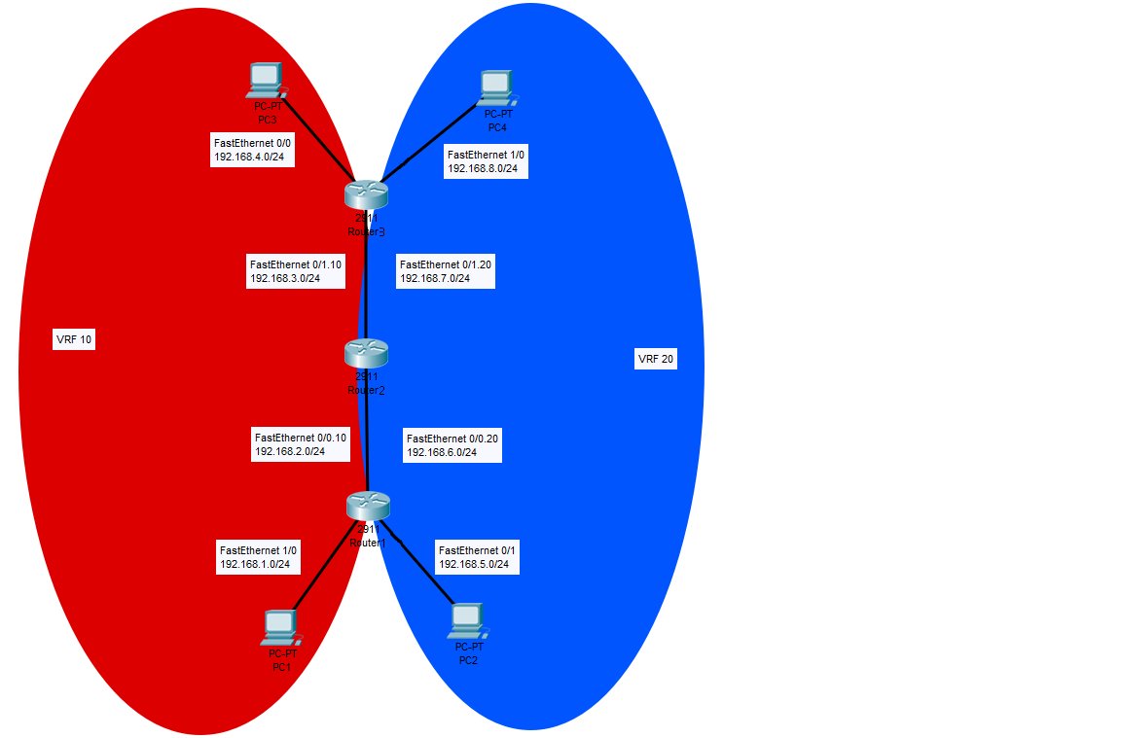

Router Configurations

-------------

Router 1

-------------

R1#sh run

Building configuration...

Current configuration : 1778 bytes

version 12.4

service timestamps debug datetime msec

service timestamps log datetime msec

no service password-encryption

hostname R1

boot-start-marker

boot-end-marker

no aaa new-model

memory-size iomem 5

no ip icmp rate-limit unreachable

ip cef

no ip domain lookup

ip vrf 10

ip vrf 20

multilink bundle-name authenticated

archive

log config

hidekeys

ip tcp synwait-time 5

interface FastEthernet0/0

no ip address

duplex auto

speed auto

interface FastEthernet0/0.10

encapsulation dot1Q 10

ip address 192.168.2.1 255.255.255.0

interface FastEthernet0/0.20

encapsulation dot1Q 20

ip address 192.168.6.1 255.255.255.0

interface FastEthernet0/1

ip address 192.168.5.1 255.255.255.0

duplex auto

speed auto

interface FastEthernet1/0

ip address 192.168.1.1 255.255.255.0

duplex auto

speed auto

interface FastEthernet2/0

no ip address

shutdown

duplex auto

speed auto

interface Serial3/0

no ip address

shutdown

serial restart-delay 0

interface Serial3/1

no ip address

shutdown

serial restart-delay 0

interface Serial3/2

no ip address

shutdown

serial restart-delay 0

interface Serial3/3

no ip address

shutdown

serial restart-delay 0

router ospf 1

log-adjacency-changes

network 192.168.1.0 0.0.0.255 area 0

network 192.168.2.0 0.0.0.255 area 0

router ospf 2

log-adjacency-changes

network 192.168.5.0 0.0.0.255 area 0

network 192.168.6.0 0.0.0.255 area 0

no ip http server

no ip http secure-server

ip forward-protocol nd

no cdp log mismatch duplex

control-plane

line con 0

exec-timeout 0 0

privilege level 15

logging synchronous

line aux 0

exec-timeout 0 0

privilege level 15

logging synchronous

line vty 0 4

login

end

-------------

Router 2

-------------

R2#sh run

Building configuration...

Current configuration : 2030 bytes

version 12.4

service timestamps debug datetime msec

service timestamps log datetime msec

no service password-encryption

hostname R2

boot-start-marker

boot-end-marker

no aaa new-model

memory-size iomem 5

no ip icmp rate-limit unreachable

ip cef

no ip domain lookup

ip vrf 10

ip vrf 20

multilink bundle-name authenticated

archive

log config

hidekeys

ip tcp synwait-time 5

interface FastEthernet0/0

no ip address

duplex auto

speed auto

interface FastEthernet0/0.10

encapsulation dot1Q 10

ip vrf forwarding 10

ip address 192.168.2.2 255.255.255.0

interface FastEthernet0/0.20

encapsulation dot1Q 20

ip vrf forwarding 20

ip address 192.168.6.2 255.255.255.0

interface FastEthernet0/1

no ip address

duplex auto

speed auto

interface FastEthernet0/1.10

encapsulation dot1Q 10

ip vrf forwarding 10

ip address 192.168.3.1 255.255.255.0

interface FastEthernet0/1.20

encapsulation dot1Q 20

ip vrf forwarding 20

ip address 192.168.7.1 255.255.255.0

interface FastEthernet1/0

no ip address

shutdown

duplex auto

speed auto

interface FastEthernet2/0

no ip address

shutdown

duplex auto

speed auto

interface Serial3/0

no ip address

shutdown

serial restart-delay 0

interface Serial3/1

no ip address

shutdown

serial restart-delay 0

interface Serial3/2

no ip address

shutdown

serial restart-delay 0

interface Serial3/3

no ip address

shutdown

serial restart-delay 0

router ospf 1 vrf 10

log-adjacency-changes

network 192.168.2.0 0.0.0.255 area 0

network 192.168.3.0 0.0.0.255 area 0

router ospf 2 vrf 20

log-adjacency-changes

network 192.168.6.0 0.0.0.255 area 0

network 192.168.7.0 0.0.0.255 area 0

no ip http server

no ip http secure-server

ip forward-protocol nd

no cdp log mismatch duplex

control-plane

line con 0

exec-timeout 0 0

privilege level 15

logging synchronous

line aux 0

exec-timeout 0 0

privilege level 15

logging synchronous

line vty 0 4

login

end

-------------

Router 3

-------------

R3#sh run

Building configuration...

Current configuration : 1754 bytes

version 12.4

service timestamps debug datetime msec

service timestamps log datetime msec

no service password-encryption

hostname R3

boot-start-marker

boot-end-marker

no aaa new-model

memory-size iomem 5

no ip icmp rate-limit unreachable

ip cef

no ip domain lookup

multilink bundle-name authenticated

archive

log config

hidekeys

ip tcp synwait-time 5

interface FastEthernet0/0

ip address 192.168.4.1 255.255.255.0

duplex auto

speed auto

interface FastEthernet0/1

no ip address

duplex auto

speed auto

interface FastEthernet0/1.10

encapsulation dot1Q 10

ip address 192.168.3.2 255.255.255.0

interface FastEthernet0/1.20

encapsulation dot1Q 20

ip address 192.168.7.2 255.255.255.0

interface FastEthernet1/0

ip address 192.168.8.1 255.255.255.0

duplex auto

speed auto

interface FastEthernet2/0

no ip address

shutdown

duplex auto

speed auto

interface Serial3/0

no ip address

shutdown

serial restart-delay 0

interface Serial3/1

no ip address

shutdown

serial restart-delay 0

interface Serial3/2

no ip address

shutdown

serial restart-delay 0

interface Serial3/3

no ip address

shutdown

serial restart-delay 0

router ospf 1

log-adjacency-changes

network 192.168.3.0 0.0.0.255 area 0

network 192.168.4.0 0.0.0.255 area 0

router ospf 2

log-adjacency-changes

network 192.168.7.0 0.0.0.255 area 0

network 192.168.8.0 0.0.0.255 area 0

no ip http server

no ip http secure-server

ip forward-protocol nd

no cdp log mismatch duplex

control-plane

line con 0

exec-timeout 0 0

privilege level 15

logging synchronous

line aux 0

exec-timeout 0 0

privilege level 15

logging synchronous

line vty 0 4

login

end

---------------

Pings R2 -> PCs

---------------

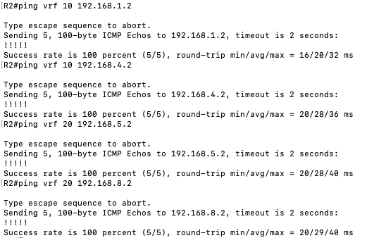

-----------------

Pings PC1 <-> PC3

-----------------

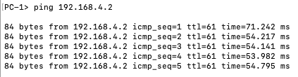

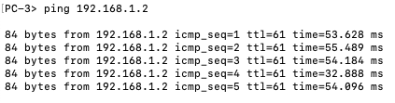

-----------------

Pings PC2 <-> PC4

-----------------

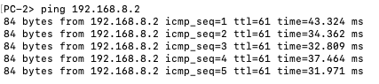

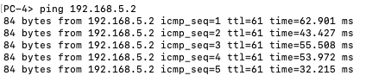

--------------------

IP Routing Table R2

--------------------

